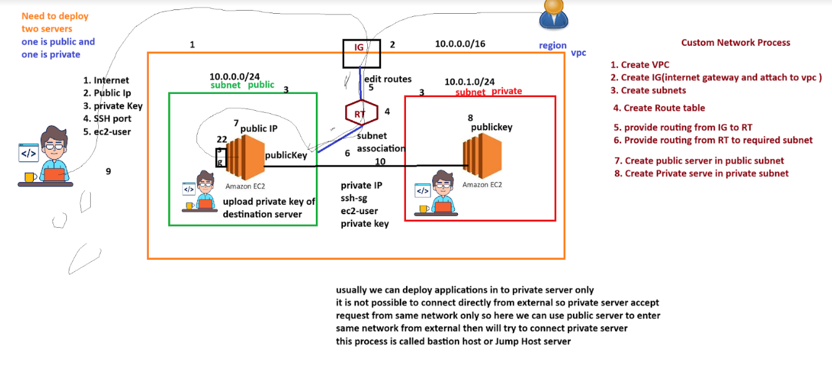

**Step1:** Create VPC

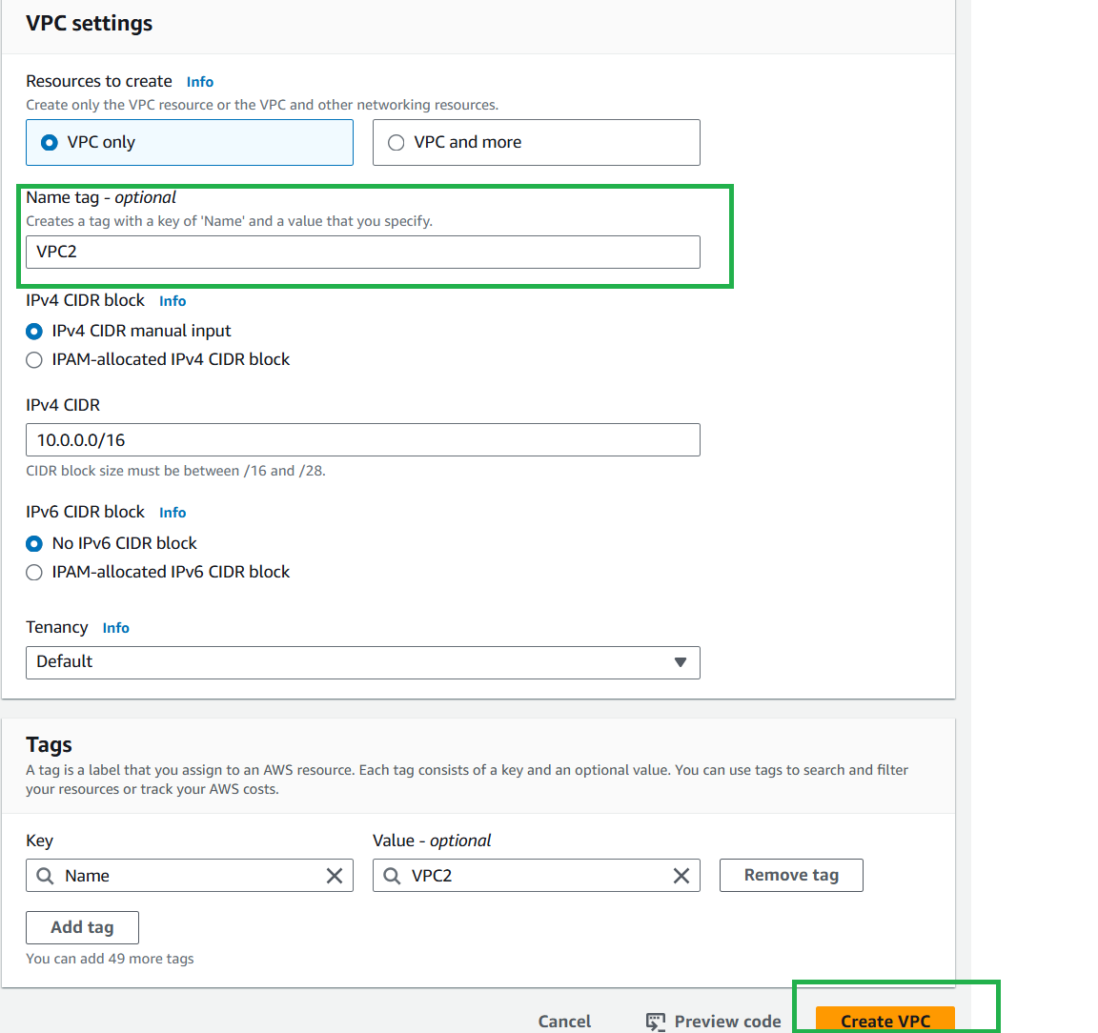

**Step2:** Create internet Gateway

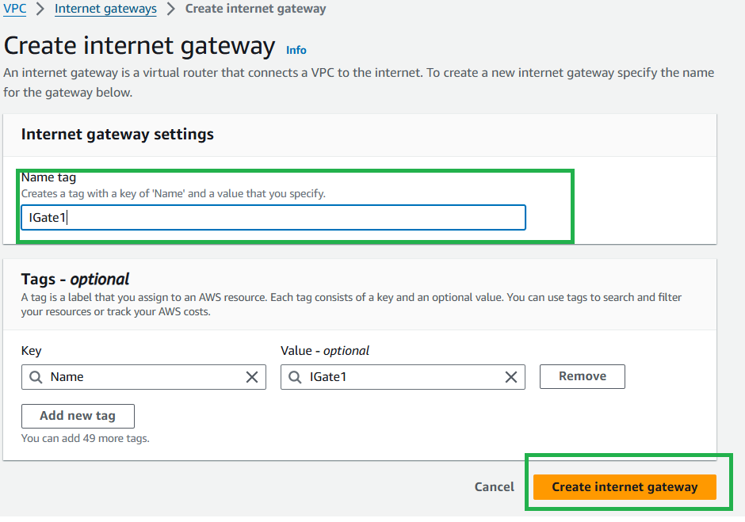

Attach VPC to Internet Gateways

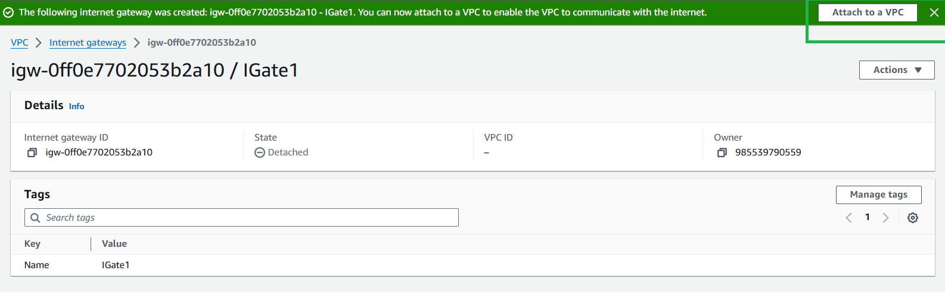

**Step3: Create Subnets**

1. **Subnet-1**

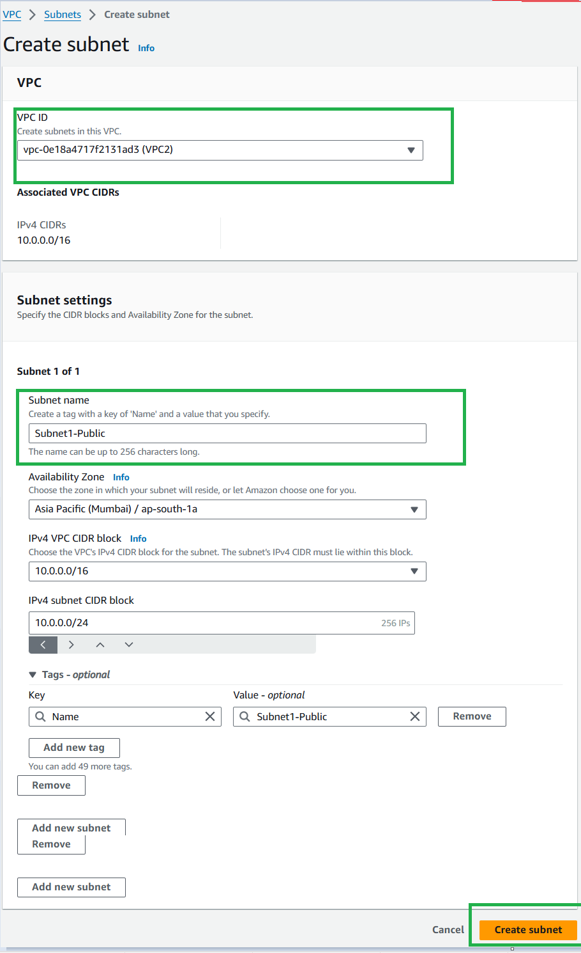

1. Subnet-2

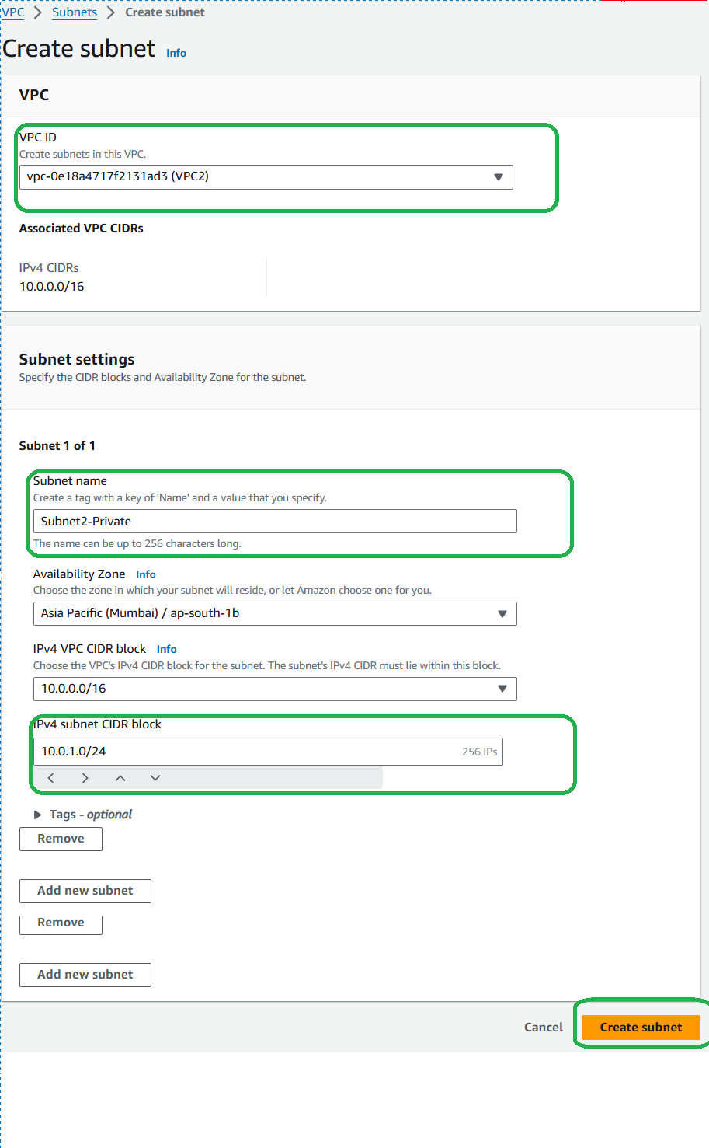

**Step4**: Create route table

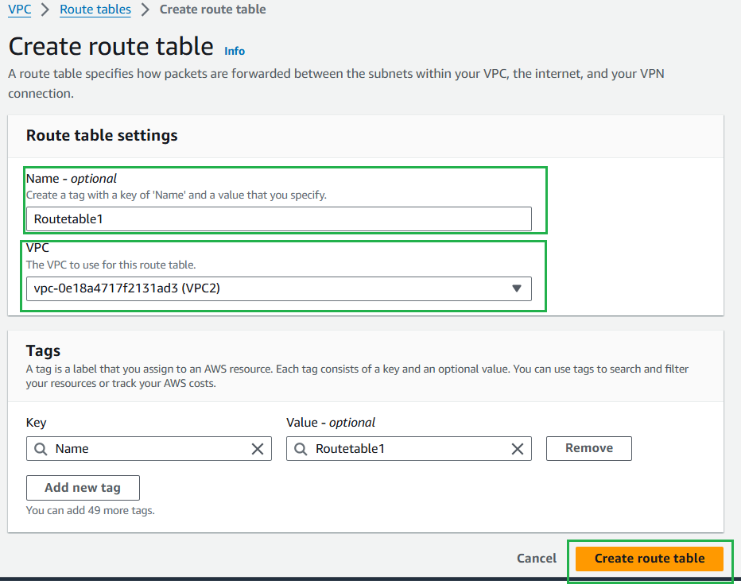

**Step5**: Provide routing from IG to Route table

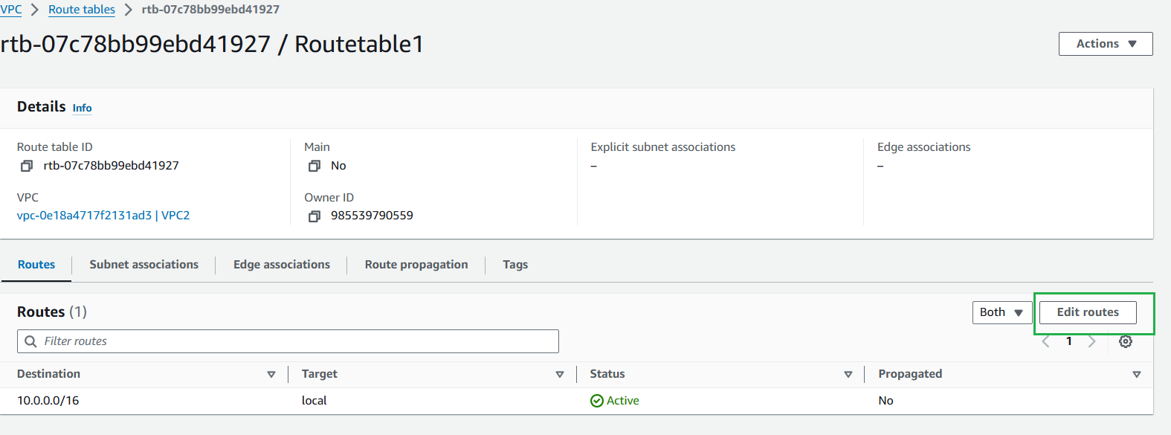

Add route

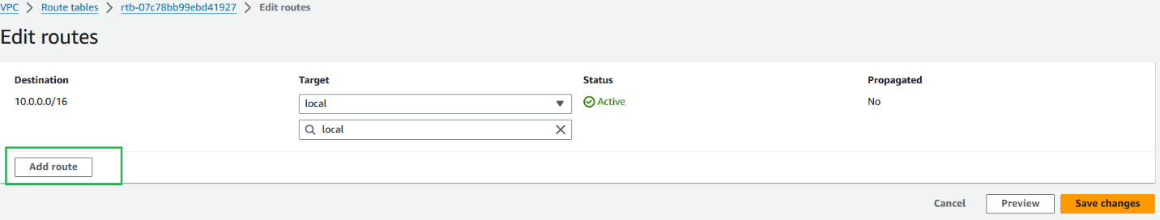

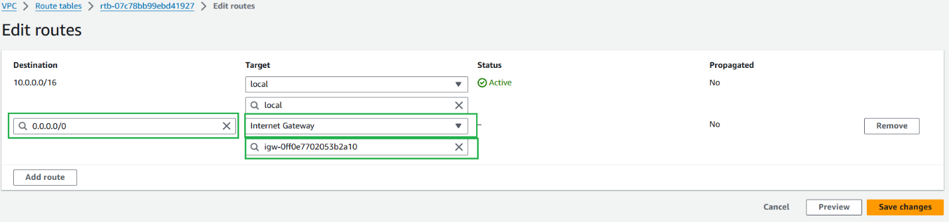

**Step 6:** Provide routing from RT to Subnet

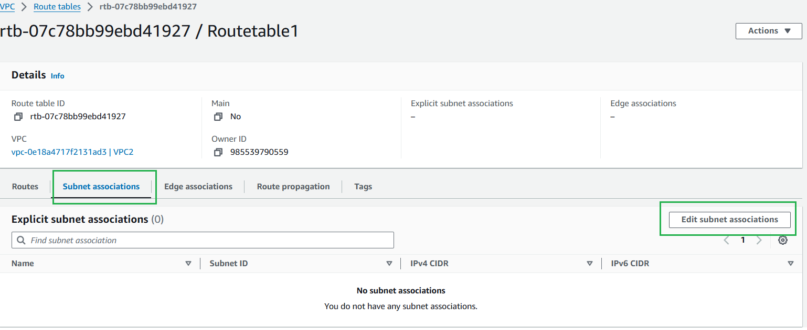

Select subnet and Save

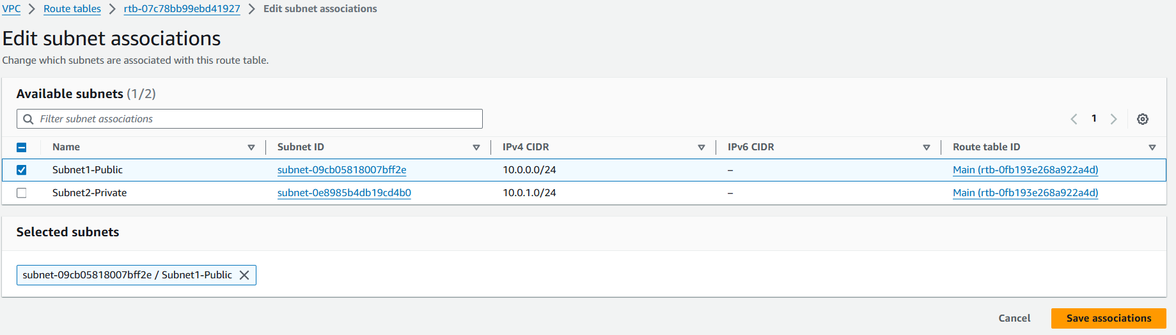

Create Security Group

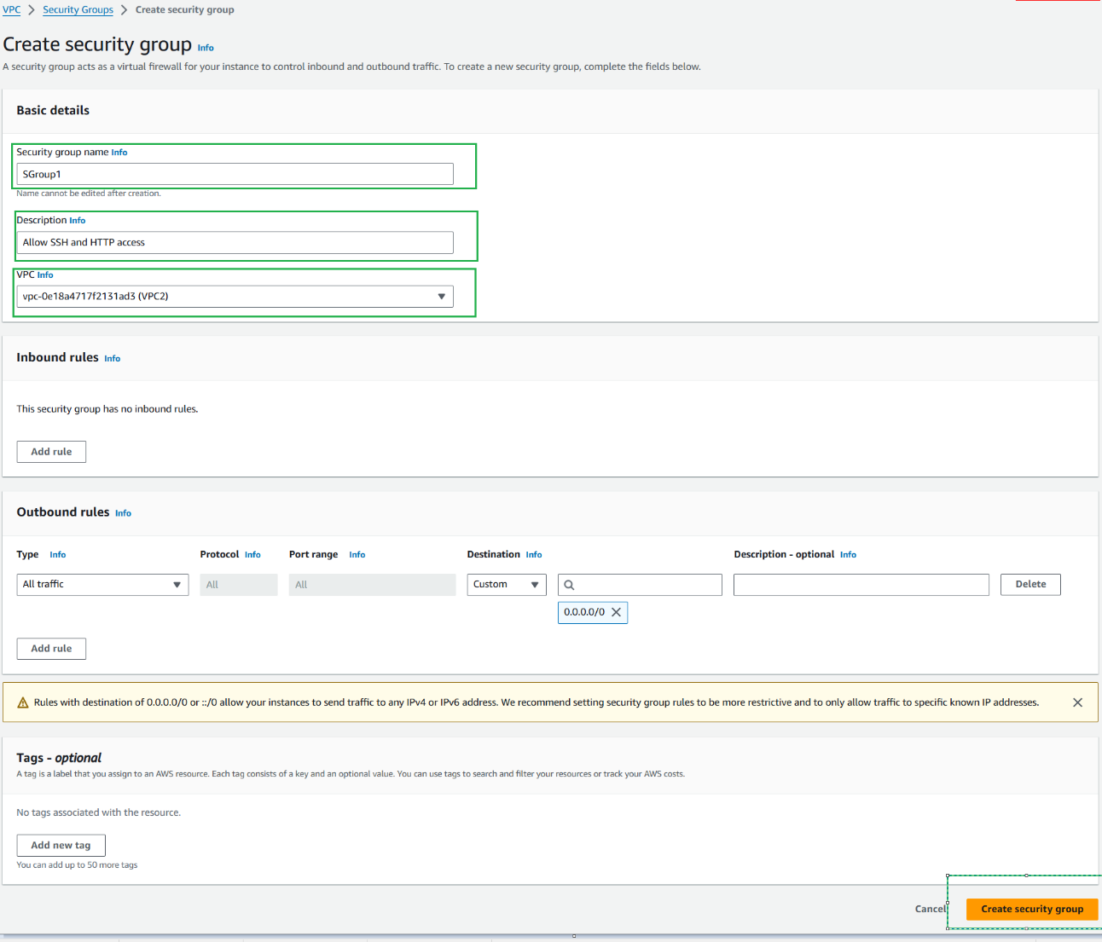

Add Inbound rules to Security Group

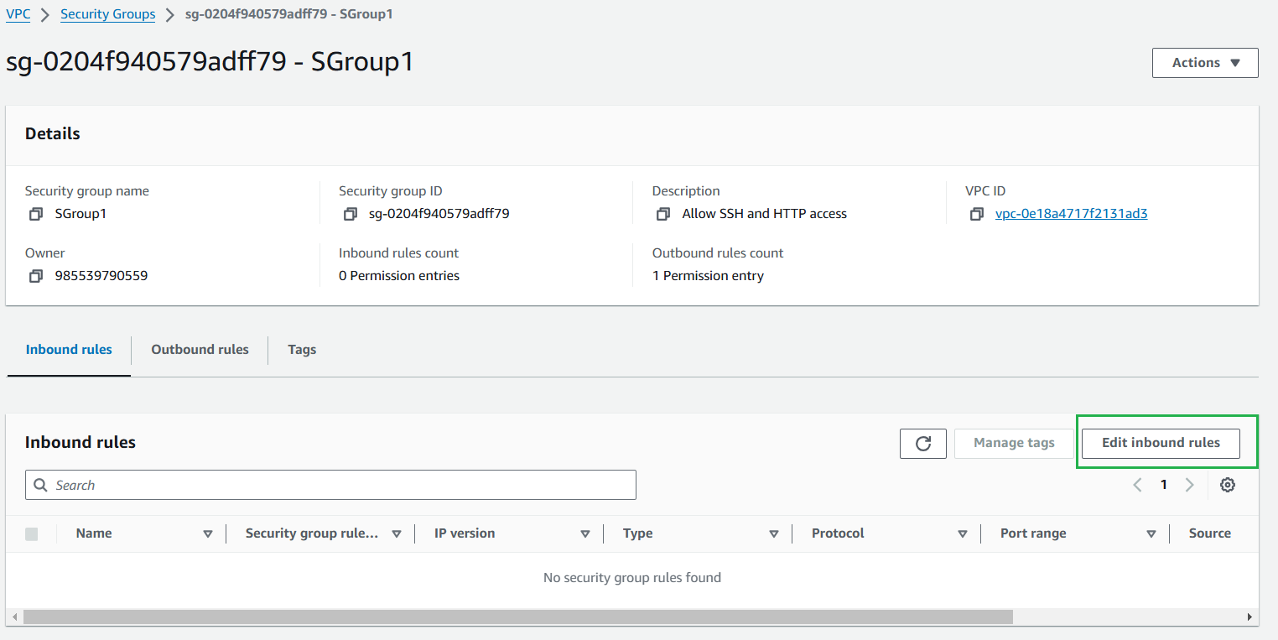

Add SSH, HTTP inbound rules

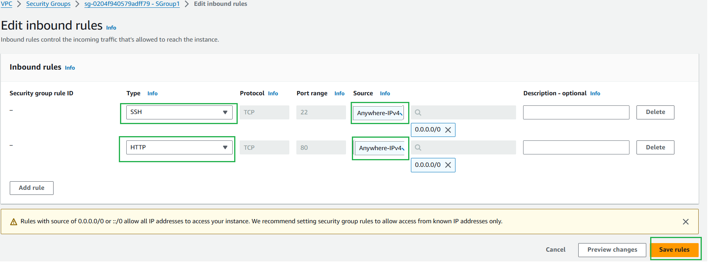

**Step7** : Create instance on public subnet

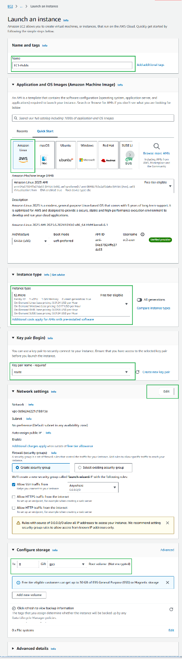

Edit Network settings and then launch

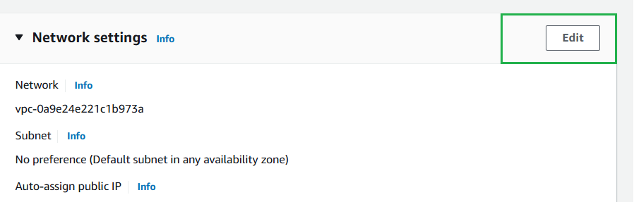

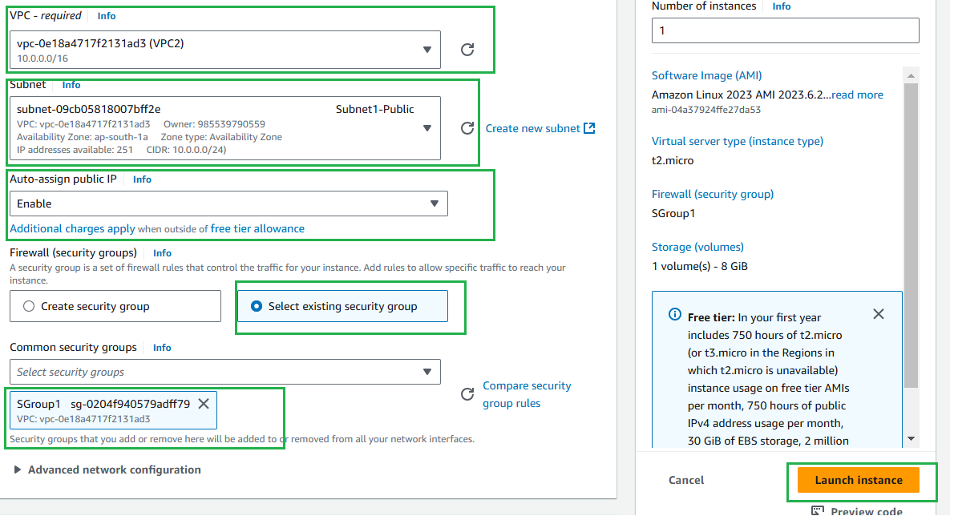

Step8: Create Instance on private subnet

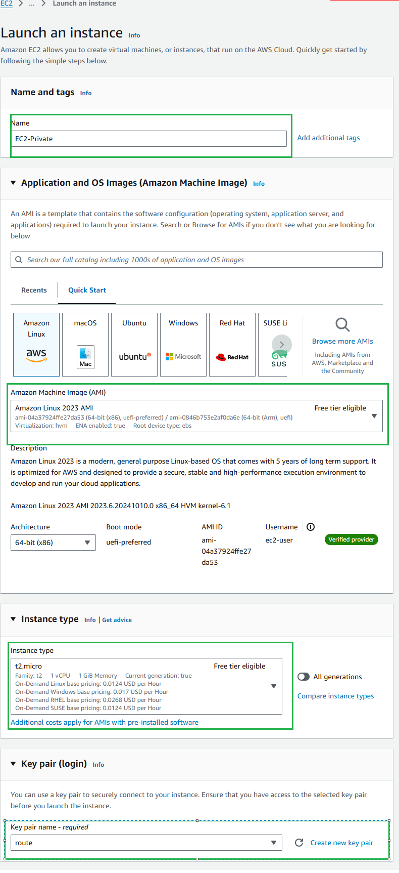

Edit Networking 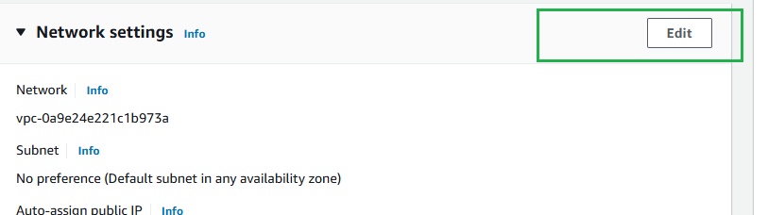

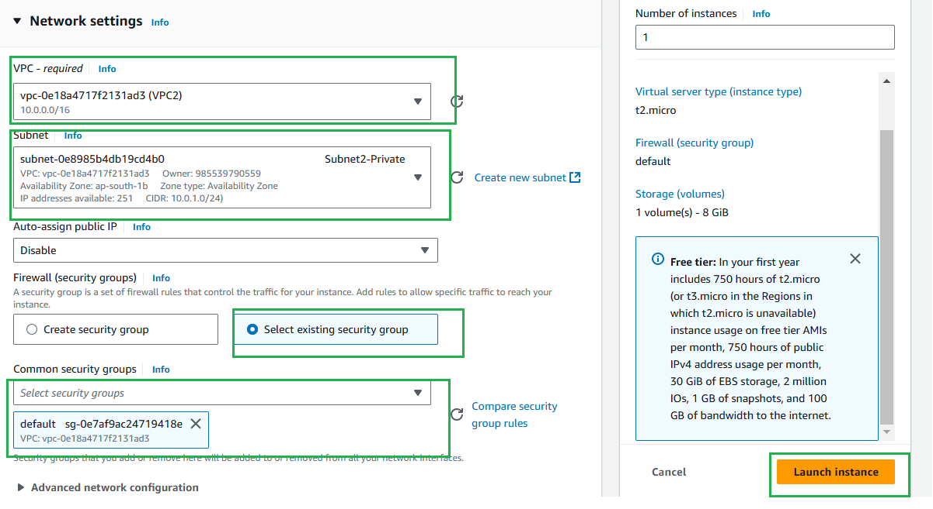

Connect instance created on public subnet using MobaXterm or other tools

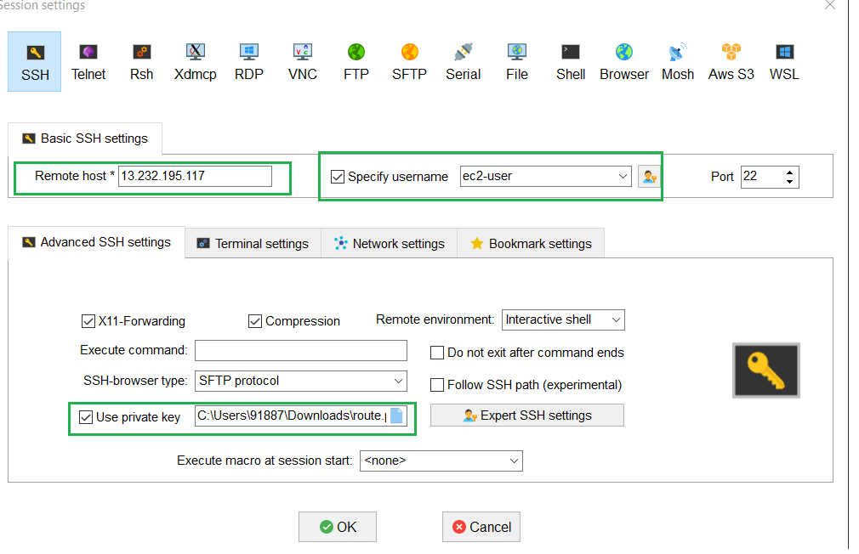

Connected successfully

